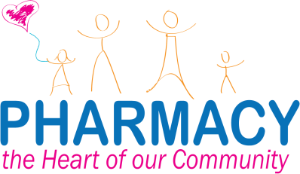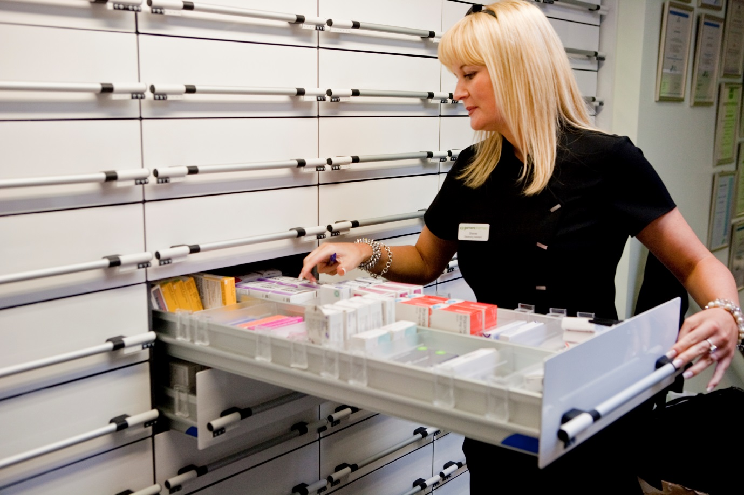

If you, or someone you care for, use the same medicines regularly, you may not need a new prescription every time you need more medicine.

Ask us about the NHS electronic repeat dispensing service.

A new way to get your regular prescriptions