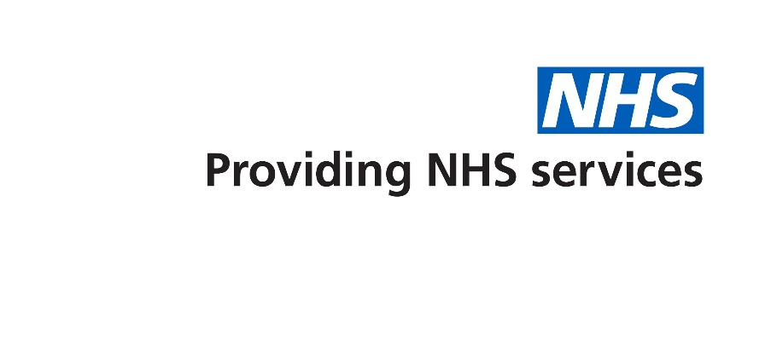

Free NHS blood pressure checks available in this pharmacy
Reduce your risk of heart and circulatory diseases

Free NHS blood pressure checks available in this pharmacy
Reduce your risk of heart and circulatory diseases

Why get your blood pressure checked?

- High blood pressure, also called hypertension, is a condition which can be controlled to reduce your risk of a heart attack, stroke or other cardiovascular disease.
- In the UK there are about five million adults (one in every nine) who have high blood pressure without even knowing it, since high blood pressure itself rarely causes symptoms.
- The British Heart Foundation estimates that high blood pressure causes over 50% of heart attacks and strokes.

What does this free NHS blood pressure check involve?

We are offering free NHS blood pressure checks to people aged 40 and over with no appointment necessary.
This involves around 10-15 minutes in the pharmacy consultation room with pharmacy staff. Following this, you may be invited to take home a blood pressure monitor that measures your blood pressure as you go about your daily life.
Depending on your blood pressure reading you may be referred to your GP. The pharmacy staff will guide you through any necessary steps depending on your blood pressure result.

Why get your blood pressure checked?

- High blood pressure, also called hypertension, is a condition which can be controlled to reduce your risk of a heart attack, stroke or other cardiovascular disease.
- In the UK there are about five million adults (one in every nine) who have high blood pressure without even knowing it, since high blood pressure itself rarely causes symptoms.
- The British Heart Foundation estimates that high blood pressure causes over 50% of heart attacks and strokes.

What does this free NHS blood pressure check involve?

We are offering free NHS blood pressure checks to people aged 40 and over with no appointment necessary.
This involves around 10-15 minutes in the pharmacy consultation room with pharmacy staff. Following this, you may be invited to take home a blood pressure monitor that measures your blood pressure as you go about your daily life.
Depending on your blood pressure reading you may be referred to your GP. The pharmacy staff will guide you through any necessary steps depending on your blood pressure result.

