Note Taking Handout

Background
Taking comprehensive clinical notes provides:
- Contemporary evidence of your clinical practice
- Demonstration of adherence to Pharmacy First PGDs and nationally commissioned pathways
- Clear handover to other providers (and the patient!)

Notes should be contemporaneous and written at the same time as a clinical encounter takes place. As part of their GP Premises inspections, the CQC1 review a sample of clinical notes to ensure:
- Notes are contemporaneous and demonstrate that staff are working within their competencies
- Records contain enough information (this includes documentation of clinical findings, investigations requested, management plans, safety netting, referrals and follow-up)
- Medicines are appropriately prescribed and monitored

Following the rise of GP-practice based pharmacists prescribers in PCNs and online pharmacies, the PDA gave the following advice regarding high risk scenarios to their members:
“The following are high-risk scenarios:
- Undertaking prescribing or providing clinical advice for patients who are not physically present
- Undertaking prescribing for patients without reference to their clinical records
- Undertaking prescribing for walk-in patients where a diagnosis may be required
- Prescribing alternative medicines due to shortages (particularly where the medicine to be replaced is a member of a high-risk group such as opiates and/or you are unfamiliar with the use of your chosen replacement). We would suggest checking with a GP or a colleague with relevant specialist experience and ensuring any online or print reference sources that are relied upon are both appropriate for the scenario in which you are prescribing and that you keep a note of those you relied upon.” ²

Regarding liability in clinical negligence cases, “The default position in clinical negligence claims is often that if something is not recorded in the records, then it did not occur. This may mean that something has been missed in a patient’s care. Should everything be recorded, then the treating clinicians are fully aware of the patient’s condition, medications, treatments and investigations and then are then able to make an informed decision on the care plan going forward. Therefore, contemporaneous records also have ability to narrow down any contentious issues and provide a defence.”³
There are a number of test cases which have underpinned the way in which the legal system has reviewed clinical negligence cases and the standards for clinicians regarding the decisions they make. Bolam v Friern Hospital Management Committee (1957) and Bolitho v City and Hackney Health Authority (1998) were predecessors to the Montgomery v Lanarkshire Health Board (2015) case.⁴ In the Montgomery case, the law on consent progressed from being clinician focussed to empowering patients to receive benefits and risks of any proposed treatments (along with the benefits and risks of any alternative treatments also), in order to make an informed decision. There have been further permutations of this in recent cases, to clarify that reasonable risks and benefits should be provided to patients (not exhaustive), but that the responsibility lies with the clinician to determine what ‘reasonable’ means.⁵
The words we record in clinical notes are powerful and our language is important. Our words can disempower patients by e.g. belittling (denies, complains), patronising (non-compliant) and blaming (poorly controlled, failure to thrive/progress).⁶

GP mythbuster 12: Accessing medical records and carrying out clinical searches. https://www.cqc.org.uk/guidance-providers/gps/gp-mythbusters/gp-mythbuster-12-accessing-medical-records-during-inspections
2 PDA urgent guidance for all PDA members following a number of critical incidents involving GP practice-based pharmacists https://www.the-pda.org/urgent-guidance-on-critical-incidents/
3 Importance of keeping contemporaneous medical notes https://www.true.co.uk/news/importance-of-keeping-contemporaneous-medical-notes/
4 . Lee A. 'Bolam' to 'Montgomery' is result of evolutionary change of medical practice towards 'patient-centred care'. Postgrad Med J. 2017 Jan;93(1095):46-50. doi: 10.1136/postgradmedj-2016-134236. Epub 2016 Jul 27
5 Dyer C. UK Supreme Court restricts scope of Montgomery duty of care to patients BMJ 2023; 382 :p1651 doi:10.1136/bmj.p1651
6 Cox C, Fritz Z. Presenting complaint: use of language that disempowers patients BMJ 2022; 377 :e066720 doi:10.1136/bmj-2021-066720

Theory and Models

Theories of how we interact in consultations and models we can follow inform our behaviour, how we structure consultations and how we make notes. There are many theories out there which I have not covered, but generally theories exist upon two spectra:
Patient centred ↔ Clinician Centred
Behaviour Orientated ↔ Task Orientated
Models and concepts we discussed this evening include:
- Roger Neighbour (1987)
- ‘Crossing the Bridge’
- Byrne and Long (1976)
- Health Belief Model (1975)
- Calgary Cambridge Model (1996)
There is a great summary of each of these and more in this free handout https://www.essentialgptrainingbook.com/wp-content/online-resources/04%20consultation%20models.pdf
The Calgary Cambridge model is the one most widely used to support new prescribers in structuring their consultations:
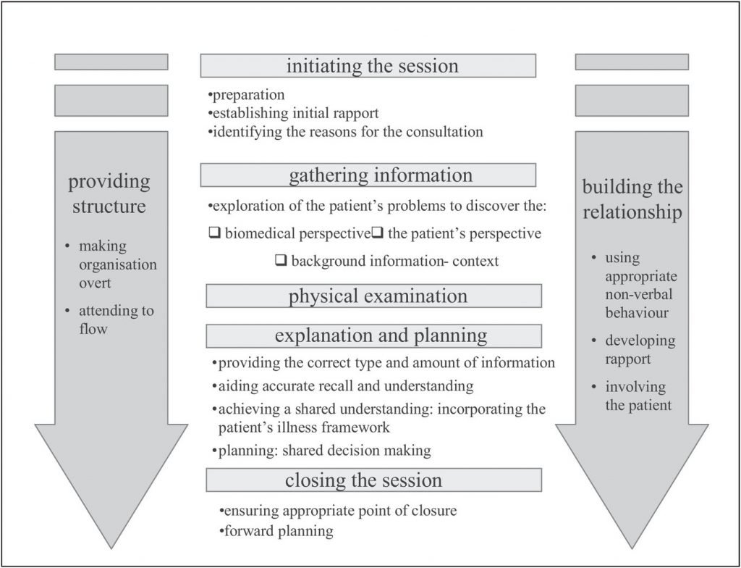
Available from: https://www.bradfordvts.co.uk/communication-skills/teach-communication-skills/calgary-cambridge/

Note Taking Walkthrough

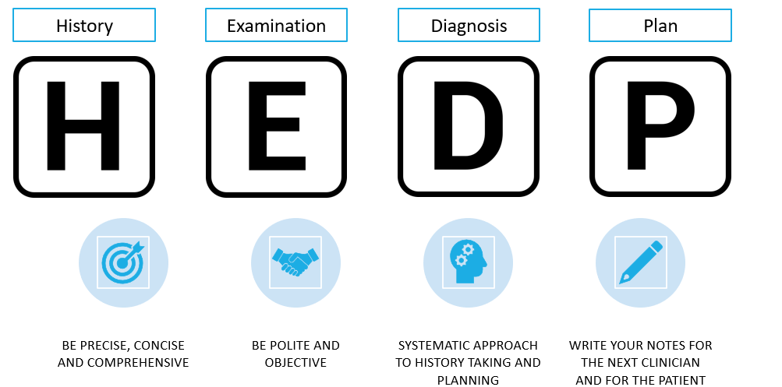
A summary of a suggested way to structure your notes is as follows:

Before starting with our history, we want to clerk attendance details. Aspects of this may be pre-recorded/embedded for you depending on what clinical/PMR system you are using or service template. Record:
- Date, Time, Service, Setting
- Alone or with chaperone
- Mode: Face to Face, Online, Telephone
- Contact Type: First, Follow up, Referral
- Is anyone else present in the consultation room
- Who are you/Who were they seen by
History
Clerk the history in the form of a medical interview. This is a summarised (and pared down) version:
Item | Description
Presenting Complaint (PC) | What are/is the principle symptom(s)
History of Presenting Complaint (HPC) | General questions (consider SOCRATES or other tools) consider any therapies that have already been tried.
Past Medical History (PMHx) | Any other conditions, surgery
Drug History (DH) | May have some of this in the PMR already. Include OTC, Herbal and recreational drugs also. Allergies.
Social History (SH) | Occupation, Home environment, Smoking status, Alcohol, Weight, Diet (Can be difficult – abuse, sexual history)
Review of Systems (RoS)  aka Systematic Enquiry (S/E) | System specific questions dependent on history. Helps to establish diagnosis, identify red flags and rule out differentials.

A full description, along with further clerking tips can be found here https://geekymedics.com/clerking-101/
You may wish to use acronyms such as ASMETHOD, SOCRATES (Site, Onset, Character, Radiation, Associated Symptoms, Time/Duration, Exacerbating/ alleviating factors, Severity) or OLDCARTS to support your HPC. These were developed for pain history taking, but have found wider application in general HPC.

Examination
Can be denoted as O/E (On Examination)
Include your first impressions and initial assessment here also – does the patient appear unwell? Consider your ‘End-o-bed-o-gram.’ Are they able to walk unassisted to the consultation room?
State the examination in your notes, but do not describe it. Record what you found and also what you did NOT find that is pertinent to your line of enquiry.
NAD is often used to denote No Abnormality Detected/ Nothing Abnormal Detected (i.e. normal).
Give units for any readings taken.
You can also consider how the patient is talking (in full sentences? Tone of voice, rate of speech, open/closed answers, are they tearful?) as part of your examination, as well as their body language (guarding, eye contact). Ensure when recording this you remain objective and report what is you are observing as opposed to what you interpret these to mean.

Diagnosis or Impression
Generally one or two lines maximum.
Needs to be clear and simple.
Can also list differentials.
Indicate uncertainty with a question mark.
Omit if there is no diagnosis or impression.

Plan
Safetynetting is really important – both the advice we give and the time frame. Neighbour advocates asking three questions to help inform this:¹
- If I’m right, what do I expect to happen?
- How will I know if I’m wrong?
- What would I do next?
Advice needs to be patient specific – red flags, escalation and time bound.
Include details of any agreed follow up in your notes.
Your plan should be clear and stepwise (numbering the points is good practice).
Give any treatment provided or stopped, along with risks and benefits.
Record the advice you give and whether written information was provided to supplement this.
Consider if someone else can understand your plan from your notes – this might be the first thing the next clinician sees if the patient escalates to another care setting.

¹Neighbour, R. (2005). The Inner Consultation: How to Develop an Effective and Intuitive Consulting Style, Second Edition (2nd ed.). CRC Press. https://doi.org/10.1201/9780203736548

Appropriate abbreviations

Setting – F2F (Face to face)
Sections of the Medical Interview – PC, HPC, PMH(x), DH(x), SHx, RoS
Ideas, Concerns, Expectations – ICE
Allergies – NKDA (none)
Examinations – BP, RR, (O2)Sats, HR, Temp
Dosing – od, bd, tds etc
Blood tests – TFT, FBC, LFT etc
Prescribed therapy - Rx
Contextualised abbreviations – E.g. Otoscopy…. R Ear.
+ a lot ++ lots and lots
-ve negative, +ve positive
? Unsure

There is a good guide around common abbreviations here (however, some are hospital specific or could be ambiguous, so take with a pinch of salt and if unsure, contextualise or don’t use them) https://www.stthomasmedicalgroup.co.uk/wp-content/uploads/2015/05/Common-Abbreviations-1.pdf
The NHS website also has a good list of common abbreviations https://www.nhs.uk/nhs-app/nhs-app-help-and-support/health-records-in-the-nhs-app/abbreviations-commonly-found-in-medical-records/
Be wary of AMBIGUOUS or niche abbreviations – a list of many of these can be found in this article https://www.ismp.org/resources/medical-abbreviations-have-contradictory-or-ambiguous-meanings

Tips and Pitfalls

Common Pitfalls
Waffle/prose
Unclear next steps or No plan
No safety netting/escalation advice
Including judgements instead of fact
Duplicating effort (e.g. writing up notes on paper and then transposing)
‘Saving’ write ups for later
Ambiguous/Niche Abbreviations

Top Tips
Ensure note taking is contemporaneous
Announce to the patient what you will be doing
If routinely consulting remotely, invest in a headset
Don’t leave the consultation room until you’re finished(!)
Be exacting, comprehensive and concise
Be polite
Be objective
Support any opinions with evidence
Provide a clear, stepwise plan
Reflective Practice (can you either record your own consultations and listen back later? Or ask a colleague to sit in and give constructive feedback? Or observe other people who run clinics regularly?)

Further Reading

Hopcroft, K., & Forte, V. (2020). Symptom sorter (Sixth edition.). Taylor & Francis Group.

Douglas, G., Nicol, F., Robertson, C., & Robertson, C. S. L. in E. M. C. (2013). Macleod’s Clinical Examination (Thirteenth edition.). Elsevier.

Cooper, N. & Frain, J. (2017) ABC of Clinical Reasoning. Wiley & Sons

Johnson, G., Hill-Smith, I., & Bakhai., C. (2018) The Minor Illness Manual (5th Edition) CRC Press

Also check out the RPS Library for titles in the Oxford Handbook Series, Symptom Sorter and the latest edition of Symptoms in the Pharmacy.

RCP Generic medical record keeping standards - https://www.rcplondon.ac.uk/projects/outputs/generic-medical-record-keeping-standards

Geekymedics clerking 101 - https://geekymedics.com/clerking-101/

PRSB Standards for the Structure and Content of Health and Care Records (Long Reference Doc) https://www.rcplondon.ac.uk/projects/outputs/standards-clinical-structure-and-content-patient-records

