Community pharmacy and primary care pharmacy team newsletter – COVID early treatment
Background
Groups of patients who would be eligible for treatment for COVID-19 infections is widening to include more medical conditions and age groups:
- People aged 85 or over.
- End-stage heart failure with a long-term ventricular assistance device.
- People on the organ transplant waiting list.
- People aged over 70 who have a BMI of >35, diabetes or heart failure, patients in care homes).
See below for NICE update letter:
1.4 million more people at risk of severe COVID-19 to have access to antiviral Paxlovid | News | News | NICE
Scope
Primary care providers can prescribe Paxlovid tablets for patients in the community who test positive for COVID-19 and are at risk of deterioration from the infection to enable early treatment and avoid hospital admission. It has been classified as “Green” on the Devon Formulary which enables Primary care providers to prescribe this.
Community Access to Neutralising Monoclonal Antibodies (nMAB) and Oral Antivirals for Covid-19 Treatment - South & West (devonformularyguidance.nhs.uk)
Community pharmacies will be supplying Paxlovid tablets against a prescription issued by a GP/primary care prescriber. Due to the tablets containing ritonavir as an adjuvant to increase the effectiveness of the active ingredient nirmatrelvir, there are several interactions that will concern the use of Paxlovid tablets with a patient’s regular medication.
Ritonavir is an enzyme inhibitor of CYP3A4 and CYP2D6 together with P-GP inhibition. It is anticipated that inhibition of these enzymes would increase concentration of co-prescribed medication. The Liverpool COVID-19 Interactions Checker and the SPCs of medicines (links below) would provide information on whether medicines interact and to what extent if the information is available.
Liverpool COVID-19 Interactions (covid19-druginteractions.org)
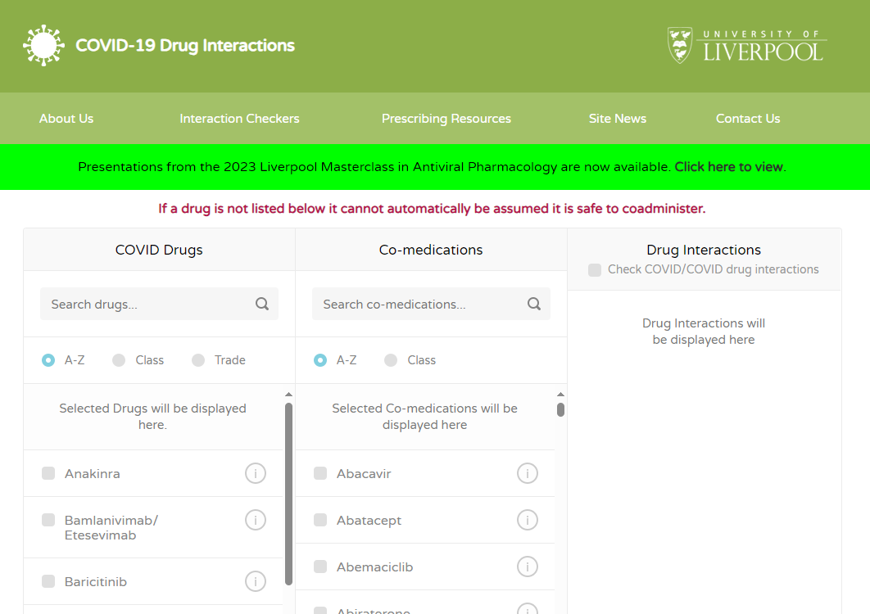
Type in “Ritonavir” on the lefter-most section and select “Nirmatrelvir/Ritonavir (5 days)” and enter co-prescribed medication or OTC/supplements/herbal medicines in the middle section and select the medication needed. The interaction details will appear on the right-hand side. Interactions are categorised into Red, Amber, Yellow or Green interactions. Green interactions are considered insignificant so can be safely taken with Paxlovid. Yellow and Amber interactions are considered significant but can be managed. Click on the information under the interaction and the checker will usually explain the extent of the interaction. Base your recommendation to the patient on this. This example below will put the Amber interactions into context:
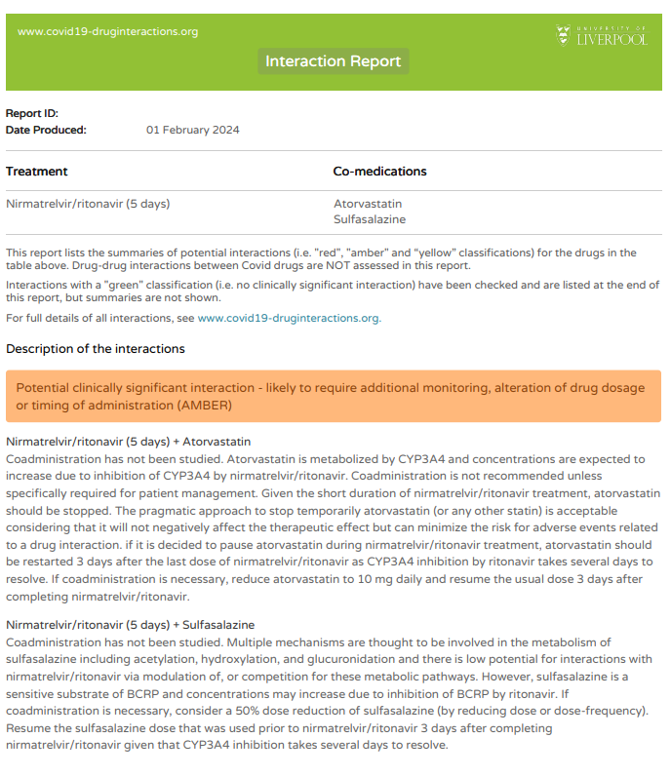
Where able to safely withhold Atorvastatin, this can be done then restarting Atorvastatin 3 days following completion of Paxlovid is acceptable. The interaction check does suggest reducing the dose of atorvastatin if it is not possible to withhold atorvastatin.
Sulfasalazine interacts with Paxlovid but there is suggestion to reduce dose by 50% if it is deemed necessary to continue treatment of sulfasalazine together with Paxlovid.
Use your professional judgment to decide on whether it is appropriate for patient to continue with regular medication while taking Paxlovid.
Red interactions are contraindicated. Use your professional judgment to decide whether the co-prescribed medication is required to be continued during the time of being prescribed Paxlovid. For example, simvastatin is a red interaction with Paxlovid, however simvastatin can be safely withheld for 8 days (5 days of Paxlovid course and 3 days following completion) so this interaction does not contraindicate the use of Paxlovid. Likewise, domperidone is a red interaction. If, following a conversation with the patient and patient is amenable to withholding this for the 8 day period then this does not contraindicate Paxlovid.
If the agent cannot be found in the Liverpool COVID Interaction Checker, check the sPC:
Home - electronic medicines compendium (emc) (login required)
Check under 4.5 – Interactions and 5.2 – Pharmacokinetic properties to look for CYP3A4, CYP2D6 and P-GP effects of co-prescribed medication with Paxlovid to ensure safety of continuing such medication.
Ordering stock
Paxlovid tablets are available to be ordered from Alliance Healthcare via the usual ordering channels. As the cost is currently funded by the government, it appears to be free on the website. So ordering Paxlovid tablets will not be at a cost.
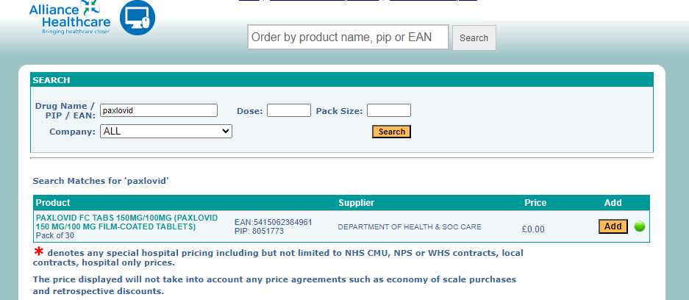
Dispensing Paxlovid tablets
Dose of Paxlovid for patients with normal renal function (eGFR >60) is 3 tablets twice a day (yellow side in the morning and blue side in the evening). In renally impaired patients the dose is 2 tablets twice a day (removing 1 nirmatrelvir tablet from each dose). Ensure each patient receives full box for the course and physically remove 2 nirmatrelvir tablets from each strip (1 from each side of strip) before supplying for patient and discard the tablets removed. See image below for what the strips look like.
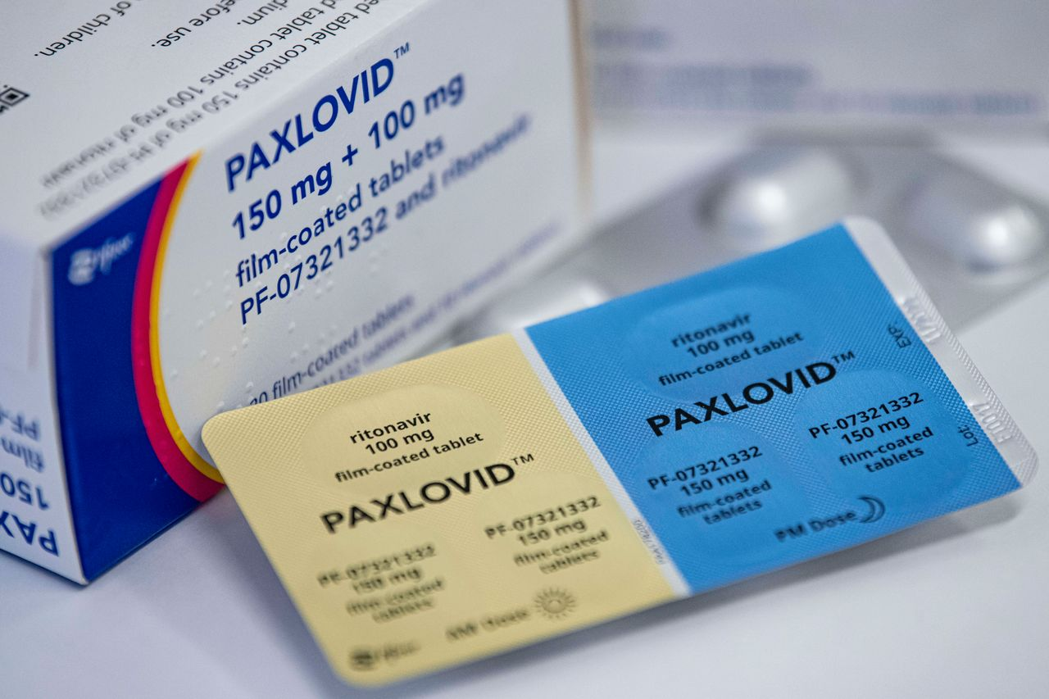
These tablets are quite large and cannot be broken prior to administration. If your patient cannot swallow solid forms of medicines then this is a contraindication.
Treatment is best started within 5 days of symptom onset/testing positive for COVID – day 0 (whichever earlier). Treatment can be initiated on days 6 or 7 with reduced efficacy, but unlikely to be effective if started after day 7. If patients remain symptomatic after day 7 of COVID infection then they would need to be referred to their GP to be reviewed as they are unlikely to benefit from early treatment of COVID.
Further questions/queries/medication supplied by secondary care
Should you have further questions following checking the Liverpool Interaction Checker and the sPC, please contact Medicines Information in Torbay Hospital on 01803655304 to ask a trained pharmacist to call you back for further advice and to obtain information specifically about medication prescribed in secondary care.
Should you think a patient is not suitable for having Paxlovid (impaired swallowing, interacting regular medicines warranting IV sotrovimab, severe hepatic impairment, etc.) please send email to CMDU in Torbay Hospital at tsdft.covidantiviraldeliveryunit@nhs.net to refer patient for review for alternative treatment choices.

