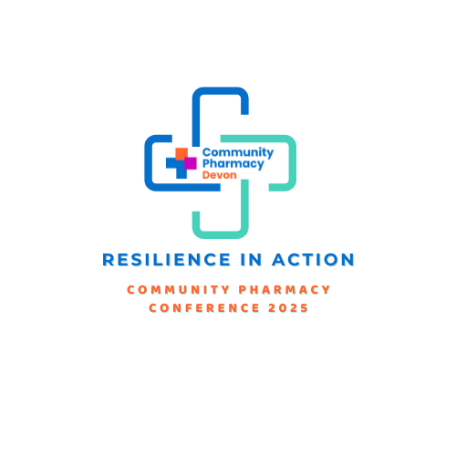

**cOMMUNITY pHARMACY dEVON cONFERENCE:**

**RESILIENCE IN ACTION – AGENDA**

**Book your place** [**here**](https://shorturl.at/n4pvw)

**LOCATION: Exeter Racecourse** **|** **DATE: 14th September 2025**  **|** **TIME: 9.00am - 4.30pm**

**8.45 - 9.20AM** **Arrivals, refreshments and sponsors** **MAIN ROOM**

**9.25 - 9.30AM** **CHAIR’S Welcome: janice perkins (director, pennine act)**  **MAIN room**

**9.30 - 9.50AM** **KEYNOTE SPEAKER – THE NEW NHS, 10-YEAR PLAN AND**

**INTEGRATED NEIGHBOURHOOD TEAMS: LIZ FIDLER (NHS England)**  **main room**

**9.50 - 10.10AM** **keynote speaker – FUTURE FOR COMMUNITY PHARMACY**  **MAIN ROOM**

**CLINICAL SERVICES (LINKED TO NHS POLICY): ANNE JOSHUA (NHS ENGLAND)**

**10.10 -10.30AM** **WHAT THIS MEANS FOR THE LOCAL HEalthcare system: main room**

**Paul green / nicola jones (primary care, nhs devon)**

**10.30 - 11.00am** **break AND SPONSORS**

**11.00 - 11.45AM** **WORKSHOP 1 – MAXIMISING pharmacy services: NATIONAL PHARMACY MAIN ROOM**

**ASSOCIATION with nick kaye** (**3rd generation pharmacist and immediate past chair NPA)**

**11.45 - 12pm** **REFRESHMENTS AND SPONSORS**

|  |  |  |  |
| --- | --- | --- | --- |
| **BREAKOUT SESSIONS** | | | |
|  | **CHANGE MANAGEMENT** | **CLINICAL** | **RESILIENCE** |
| **12 - 12.45pm** | **MANAGING PHARMACY OVERLOAD: JANICE PERKINS (director, pennine act)** | **MANAGING CLINICAL UNCERTAINTY: DAFYDD JONES(URGENT CARE CLINICAL LEAD, NHS DEVON)** | **USE OF AI TECHNOLOGY IN COMMUNITY PHARMACY – EXCITING WAYS TO FOCUS ON WHAT YOU MOST ENJOY AT WORK AND WHERE TO DEVELOP YOUR PRACTICE:**  **FRANCES TIPPETT, (SENTINEL HEALTHCARE SERVICES)** |
| **12.45 – 1.30pm** | **LUNCH AND SPONSORS** |  |  |
| **1.30 – 2.15pm** | **INDEPENDENT PRESCRIBING CASE STUDIES AND PATHFINDER:**  **WILL PIKE (COMMUNITY PHARMACIST AND IP)** | **HYPERTENSION: FOCUSED HISTORY-TAKING, GUIDELINES AND MEDS OPTIMISATION: VICKY WEBB (NON-MEDICAL PRESCRIBING LEAD, UHP)**  **AND REBECCA DUKE (COMMUNITY PHARMACIST AND IP)** | **PHARMACY WORKFORCE- NEW NEEDS; NEW WAYS OF WORKING: NICK KAYE (3rd GENERATION PHARMACIST AND IMMEDIATE PAST CHAIR, NPA)** |

**2.15 - 2.30PM** **BREAK AND REFRESHMENTS**

**2.30 - 3.00PM** **DEVELOPING WORKFORCE: wte (TBC)**

**3.00 - 3.30pm** **the university’s role in the health system and how it can support community pharmacy growth:** **Lyn Hanning (head of pharmacy practice, BATH MPHARM AT PLYMOUTH UNIVERSITY)**

**3.30 – 3.45 pm BREAK AND REFRESHMENTS**

**3.45 - 4.30PM** **DEVON COMMUNITY PHARMACY AWardS ceremony**